- The imposition of larger-than-expected tariffs on US imports will lead us to cut our UK growth forecast. Our new baseline will likely put GDP growth at just below our current forecast of 1% for this year and close to 1% for 2026, from the previous 1.5%.
- Although the higher tariffs will hit UK exports to the US, the main impact on UK growth prospects will come via weaker US and global demand and elevated trade policy uncertainty.
- The US's adoption of a minimum tariff suggests any trade deal that the UK manages to agree is unlikely to lower tariffs below 10%. In contrast to many other countries, we don't think the UK will retaliate with higher tariffs on imports from the US.
- We expect the Bank of England's Monetary Policy Committee to keep gradually cutting Bank Rate, but the more uncertain inflationary environment means the bar to pausing rate cuts is now much lower.
- The Office for Budget Responsibility will almost certainly cut its growth forecast and revise up its borrowing projections in response to the tariff increases. This adds to the likelihood that the government will need to overhaul its approach to fiscal policy in this autumn's Budget.
President Trump made his long-awaited tariffs announcement yesterday. From April 5, US imports from all economies will be subject to a tariff of 10%. As of April 9, many countries will face much higher reciprocal tariffs. There will be exceptions for some products such as steel, aluminium, cars, and car parts that are subject to tariffs that had already been announced separately. Several other sectors, including pharmaceuticals, are exempt from the reciprocal tariffs but could face their own tariffs later.
As the US runs a trade surplus with the UK, the UK was placed in the group of countries subject to the minimum 10% tariff. Around 15% of UK goods exports go to the US, representing 2.2% of UK GDP. So, although the imposition of tariffs will probably hit demand for UK exports, the direct impact on GDP is likely to be limited. But the sectoral impact will be uneven.
Chart 1: The sectoral impact of higher tariffs will be uneven
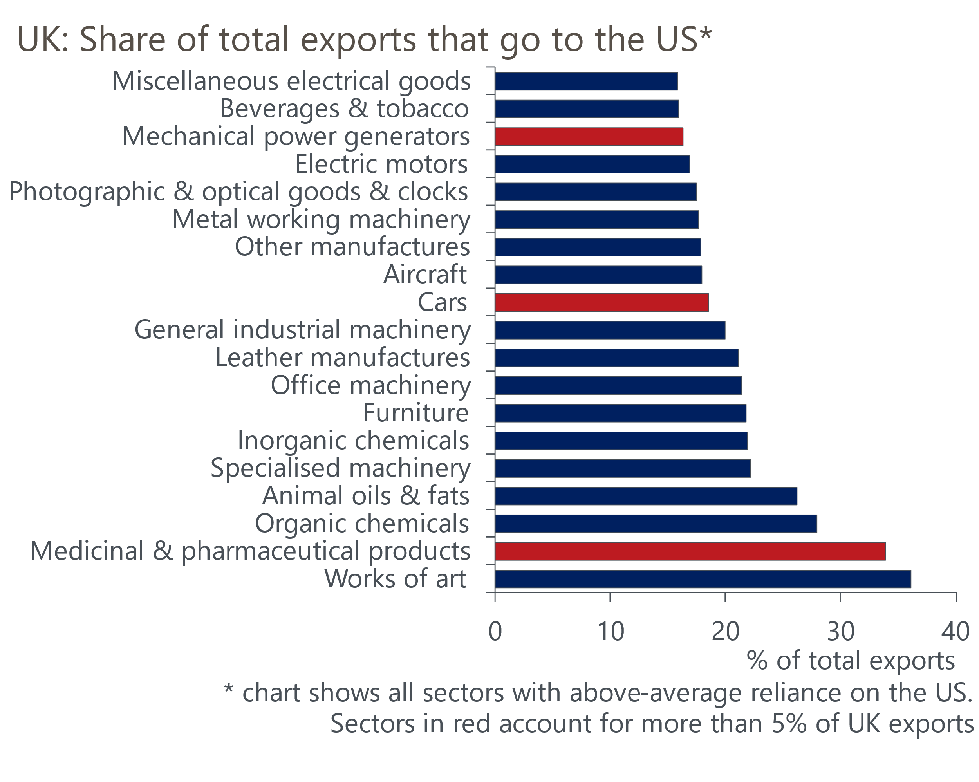
Source: Oxford Economics calculations using data from ONS

Medicinal and pharmaceutical products stands out as a relatively large sector that is heavily reliant on trade with the US (Chart 1). Although the sector is not subject to the reciprocal tariffs, it could face higher tariffs later. Mechanical power generators and cars are the other two sectors that account for more than 5% of UK exports and are more heavily exposed to the US market than the average.
The direct impact of higher US tariffs on UK output will be limited, but we expect larger indirect effects. We expect much weaker global demand than in our March baseline forecast. This is partly due to much lower US growth. The effective US tariff rate will now rise to a level last seen in the 1930s, far above the level assumed in our March baseline and, indeed, higher than the level assumed in any of our tariff scenarios. This will result in a large real income shock for US consumers.
We also expect weaker growth in other regions. This is partly due to the impact of tariffs on demand for their exports, with the universal nature of US tariffs meaning it's much harder for countries to divert exports elsewhere. It also reflects the likelihood of retaliation, with some countries imposing tariffs on their imports from the US.
We've recently noted the impact of elevated trade policy uncertainty on growth prospects. The level of uncertainty ratcheted up in the lead up to yesterday's announcement (Chart 2). Given the announcement has now been made, some of that uncertainty might drop away. But given the scope for retaliation, the uncertainty around how the US would respond to any retaliation, and the potential for countries to strike trade deals with the US, it's unlikely the degree of uncertainty will fall significantly or quickly. Elevated uncertainty is particularly toxic for business investment, and we plan to cut our capex forecasts further.
Chart 2: Trade policy uncertainty soared ahead of yesterday's announcement
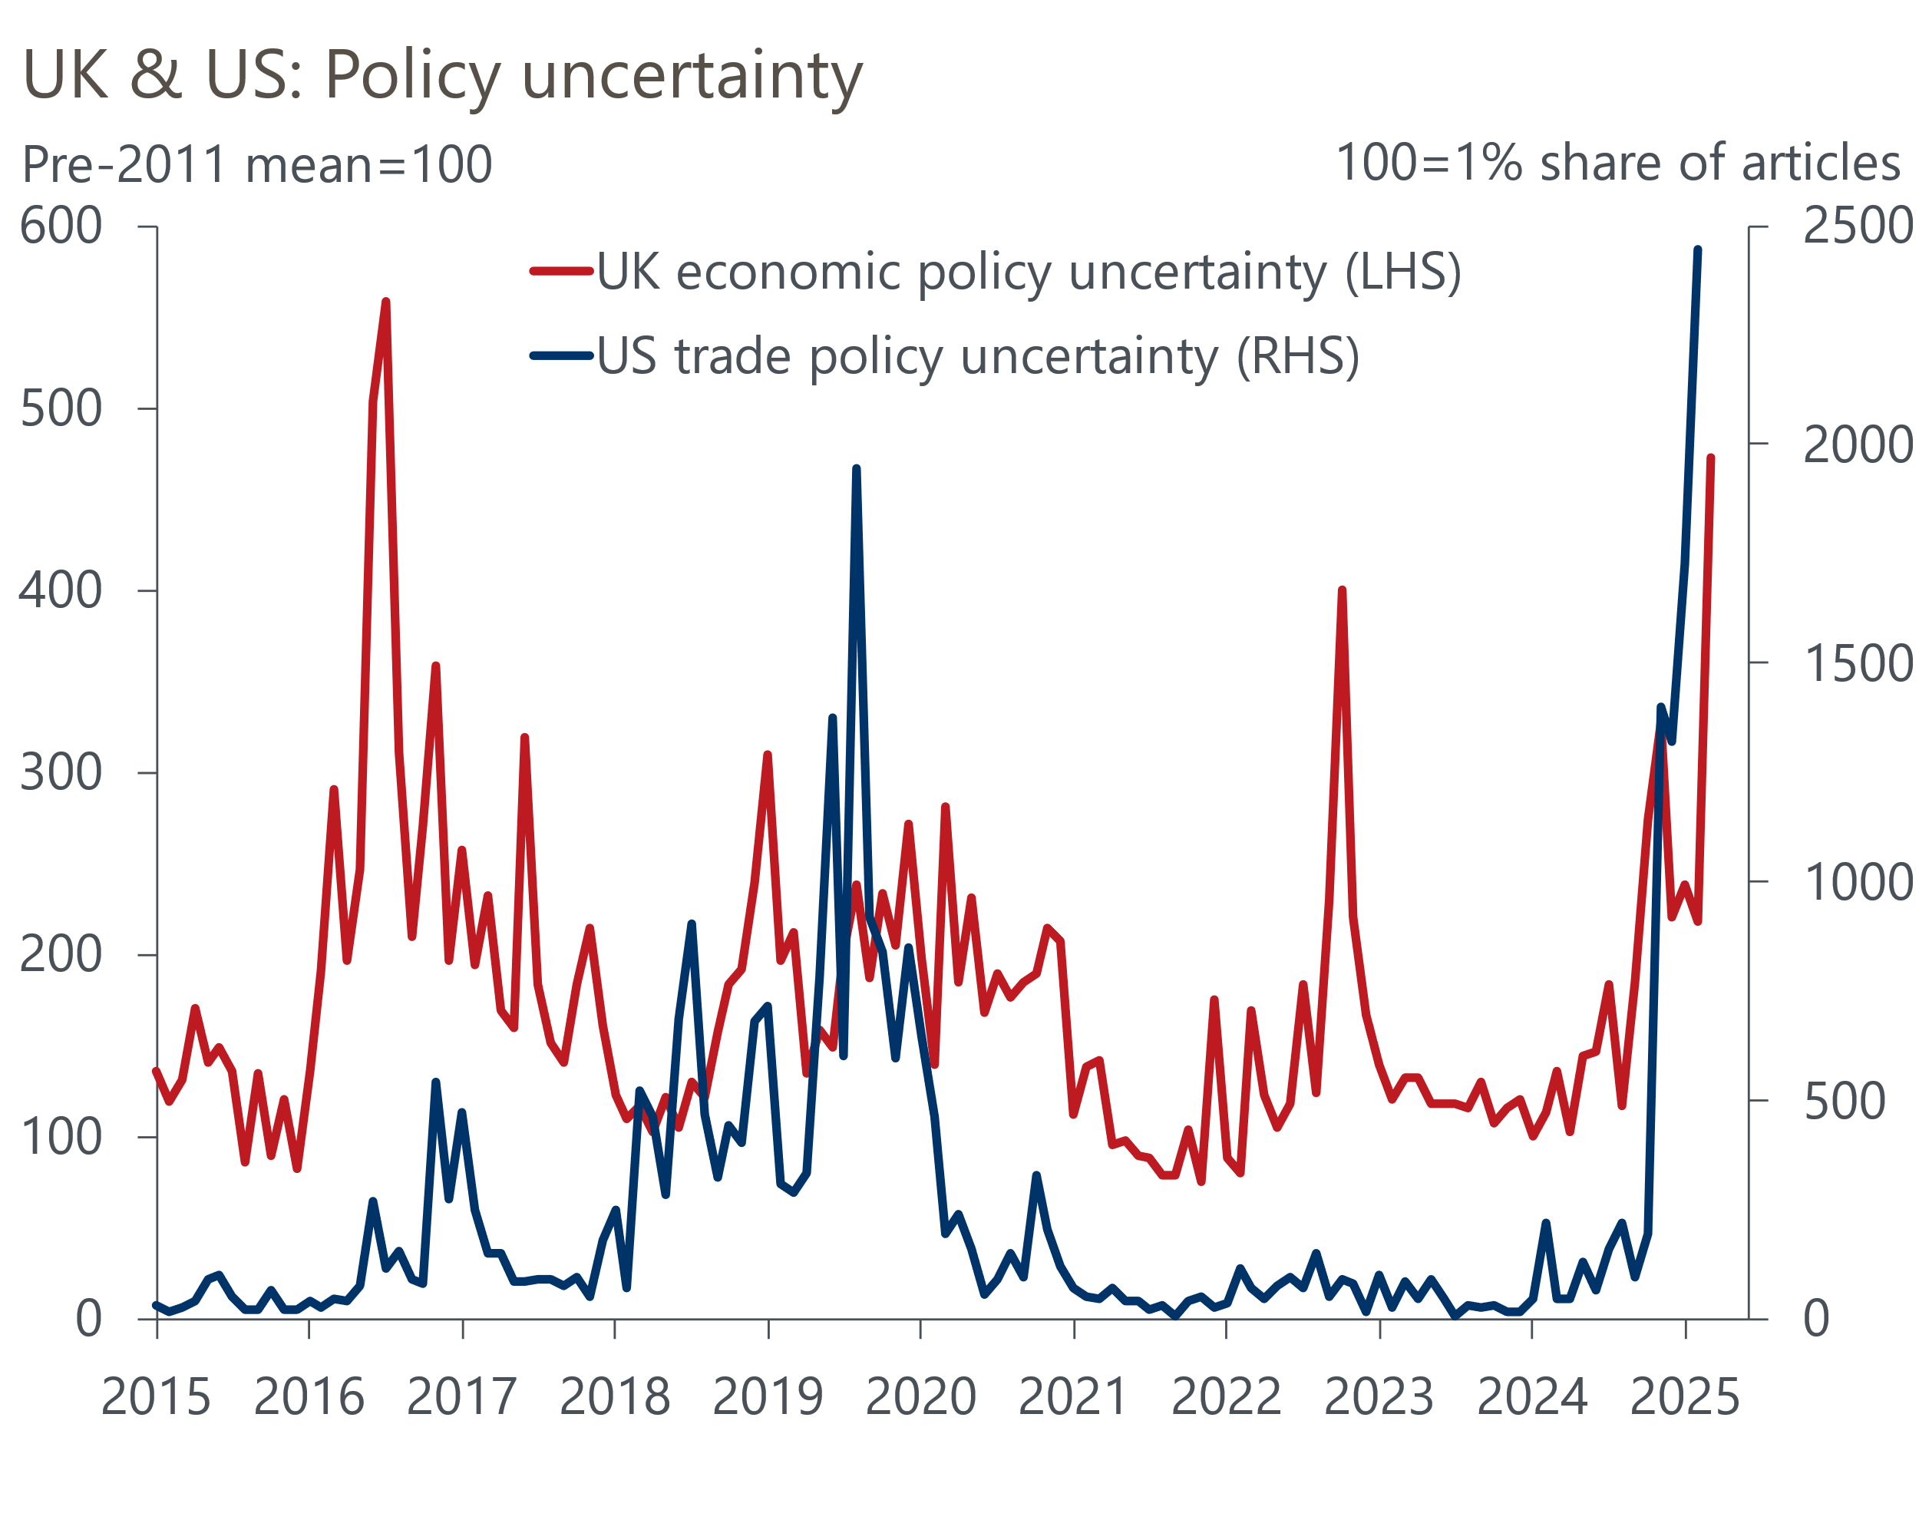
Sources: Haver Analytics, policyuncertainty.com

Growth forecasts set to be cut, but inflation impact more opaque
We will publish updated UK forecasts as part of our global forecast update on April 15. Our near-term growth forecasts will be cut. Although recent national accounts revisions provided a stronger platform for this year, we will lower our 2025 GDP forecast below 1% and we will cut our 2026 forecast from 1.5% to closer to 1%.
The impact on our inflation forecast is less clear. Based on soundings from the government, it looks unlikely that the UK will retaliate with higher tariffs on imports from the US, although it has opened a consultation with businesses. It's possible that some imported goods might become cheaper as firms target non-US markets. But we're concerned that the impact on supply chains could be significant given the scale of the tariff increases levied on many Asian economies. The impact on exchange rates and commodity prices is also far from clear cut. So, the inflationary impact looks particularly uncertain.
Our new forecasts will likely assume the new tariffs remain in place permanently. The UK government has indicated its desire to negotiate a trade deal with the US. But Trump set a high bar for countries to have tariffs removed, including removing tariffs on their own imports from the US, halting other non-tariff barriers, and purchasing “billions” of American goods. And given the UK is already at the new minimum tariff level, we're sceptical that any trade deal would involve tariffs being cut. Discussions are more likely to centre on improving market access by reducing non-tariff barriers, which are currently high in both directions.

Tariffs could reinforce the MPC's caution
The Bank of England's Monetary Policy Committee has settled into a cut-hold tempo to loosening policy. The probability of this pattern continuing until August looked high, and our March baseline forecast assumed it would continue for the remainder of 2025.
February's Monetary Policy Report contained a box on the impact of potential tariff increases that concluded the inflationary impacts were particularly uncertain. But the analysis raised the possibility that higher tariffs could damage potential output growth and the MPC already has concerns about the weakness of supply. Although it's true that the demand outlook has also worsened, against a backdrop of still-high pay growth and with memories of the inflationary impact of the last supply shock still fresh in the memory, we think this week's announcement further lowers the bar to the MPC pausing the rate-cutting cycle this year.
We’d previously identified the August meeting as being a point at which the MPC could pause, as it will be the first opportunity for the committee to digest hard data on the impact of April's increases in employers' national insurance contributions and the national living wage. There will be some evidence of the impact of US tariffs by this point, so August increasingly looks to be a key meeting for the MPC.

An overhaul of fiscal policy looks ever more certain
We called last week's Spring Statement a "stopgap" and that description looks even more apt now. The Office for Budget Responsibility published three tariff scenarios in its Economic and Fiscal Outlook. None of the OBR's scenarios maps exactly to yesterday's announcement, with the two more severe scenarios assuming 20% tariffs on US imports from the UK rather than 10%. But the assumptions for the rest of the world are in the right ballpark and, assuming we are correct about the lack of retaliation from the UK, the OBR's middle scenario looks closest to current US policy. This scenario shows almost all of the Chancellor's £9.9bn headroom disappearing.
Furthermore, changes in market pricing since the Office for Budget Responsibility locked in its financial market assumptions imply £3.4bn more borrowing in 2029-2030. So as things stand, it looks likely that the OBR will judge the government will miss its fiscal rules when it next updates its forecasts in the autumn.
This reinforces the likelihood that there will need to be a comprehensive overhaul of fiscal policy in the Budget. On top of unfavourable forecast revisions, it's likely that the government will need to increase defence spending from the planned 2.5% of GDP to 3% or more. Manifesto pledges not to increase tax will likely need to be revisited and the Chancellor may also look to squeeze spending further. Another change of fiscal rules, possibly excluding defence spending, cannot be ruled out.

